Student's Name
Professor's Name
Course
Date
Sex Trafficking
Background to the Issue
Sex trafficking is a form of modern-day slavery and a branch of human trafficking, specifically sexual exploitation. Sexual trafficking is branded as modern slavery since the victims are forced into non-consensual sexual acts, like sexual slavery. The Trafficking Victims and Protection Act, 2000 defines sex trafficking as the harbouring, recruitment, obtaining, provision, soliciting, or patronizing of a person for the aim of commercial sex act ("CDC" np). The perpetrators of sexual trafficking are called pimps or sexual traffickers. The sexual traffickers manipulate their victims into committing various types of sexual activity with paying customers. The sexual traffickers get their victims through force, coercion, and fraud to conscript, transport and offer their victims as prostitutes.
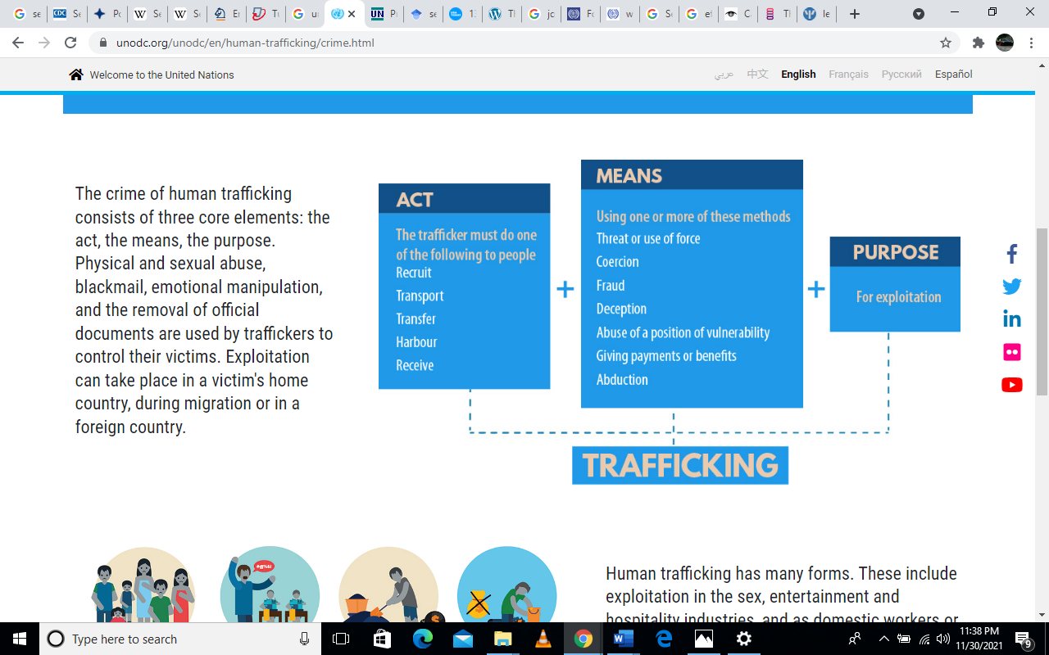 The traffickers use the emotional and financial dependency of their victims to bring them into the crime. Every phase of sexual trafficking is labelled as a crime, from acquisition and transportation to victims' exploitation. The crimes labelled thus encompass all forms of sex trafficking, including minor or adult sex trafficking, domestic minor sex trafficking (DMST) and child sex tourism (CST) (Hammond and McGlone np).
Scope of the Problem
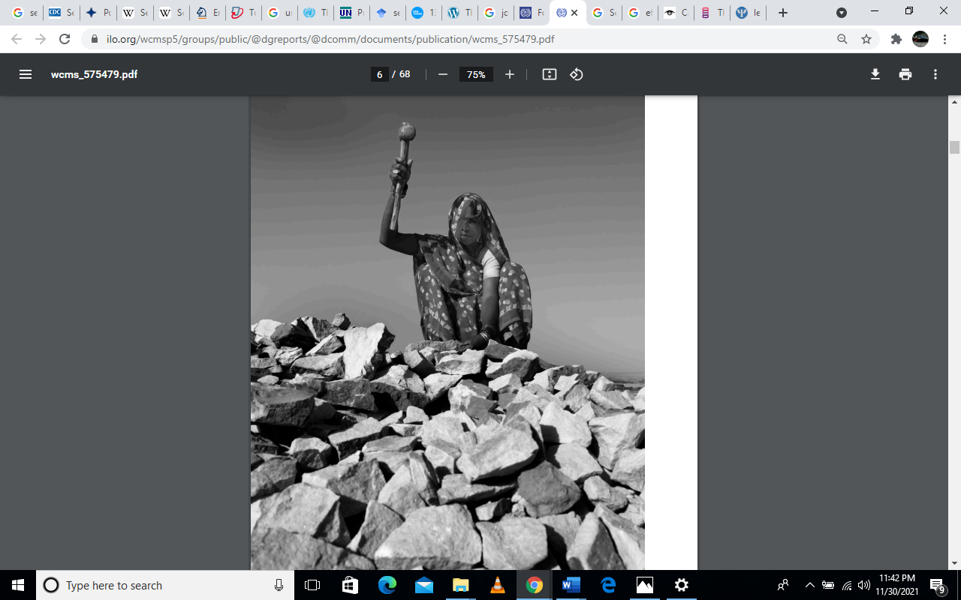
The abomination of slavery seemed like a thing of the past fifty years ago. But presently, it looks like history is coming back complete cycle. Human trafficking is a sickening reality once more. People are being trafficked globally at the moment; 2.4 million people have been abducted and sold to forced labour, with approximately 600,000 to 800,000 trafficked internationally (Dearnley np). Of this number, about 12,000 are children forced to work in cocoa farms across West Africa (Dearnley np). The crime of human trafficking grows bigger every year, but estimating the scale of the operation is difficult.
The secretive nature of sex trafficking means that getting accurate data on the number of human trafficking victims sold into sexual slavery is impossible. The International Labour Organization (ILO) states that about 40.3 million individuals are held in modern slavery at any given time. Of this number, approximately 15.4 million are pushed into forced labour and 24.9 million into non-consensual work ("International Labour Organization" np). The numbers mean that for every 1,000 people, there are about 5.4 people in modern-day slavery "International Labour Organization" np). A quarter of the people in modern-day slavery are children. The organization estimates that of the 24.9 people abducted into forced labour, 16 million work in the private sector like agriculture, domestic work or construction. Four million persons are in modern slavery imposed by state authorities, and 4.8 million of them are conscripted into sexual slavery ("International Labour Organization" np).

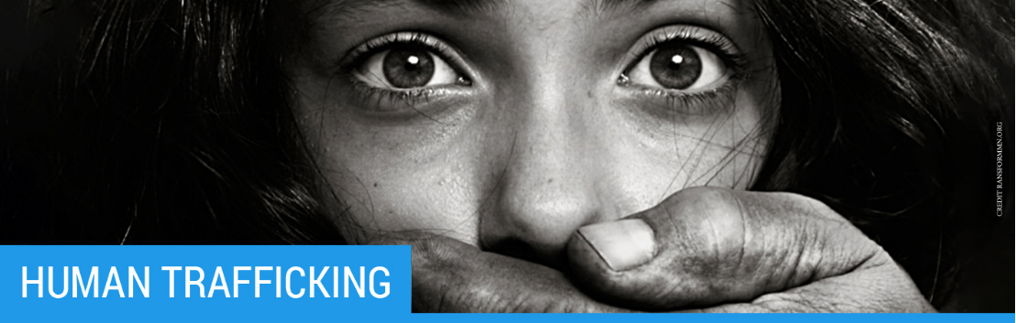
From the data, 4.8 million people were abducted into sexual exploitation in 2016 ("International Labour Organization" np). Of this number, 99% are women and girls ("ILO" 8). Looking at the distribution by region, 73% of all victims of sexual trafficking came from the Pacific areas and Asia ("ILO" 8). Europe follows it at 14%, then 8% for Africa. The Americas and the Arab States came in at 4% and 1%, respectively ("ILO" 8).
Table 1. Global Results of Modern Slavery
 |  |  | Total Forced Labour | Forced Marriage | Modern Slavery
World |  | Number (Thousands) | 24,850 | 15,442 | 40,293
Regions | Asia and The Pacific | Number (Thousands) | 16,550 | 8,440 | 24,990
Regions | Europe and Central Asia | Number (Thousands) | 3,250 | 340 | 3,590
Regions | Africa | Number (Thousands) | 3,420 | 5,820 | 9,240
Regions | Americas | Number (Thousands) | 1,280 | 670 | 1,950
Regions | Arab States | Number (Thousands) | 350 | 170 | 520

Figure 1. Regional Representation of Modern Slavery

Figure 1. Regional Representation of Sex Trafficking

A number above one million of all victims of sexual slavery were children under the age of 18 years, 21% of all victims ("ILO" 9). Under the ILO's Worst Forms of Child Labour Conventions Act of 1999, No. 182, any child found in any form of commercial sexual activity is considered a victim of sexual exploitation ("ILO" 9). Additionally, according to reports from the National Center for Missing and Exploited Children, one in every seven children of the total 25,000 children reported missing are probably fallen into child sexual trafficking (Kelly np). The efforts of child protection agents, law enforcement, or survey data collection efforts have come empty-handed since child victims of sex trafficking are very difficult to detect.
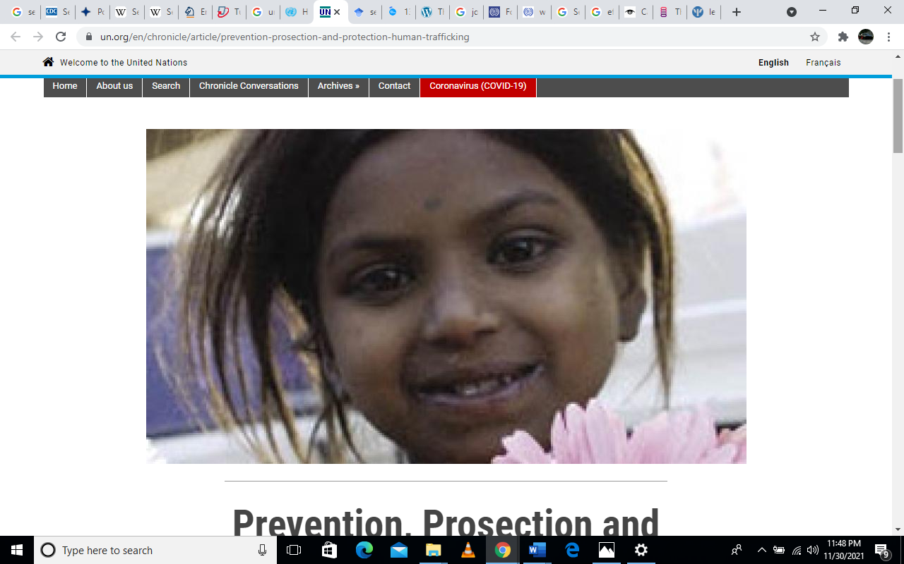
From Saar et al. (12), girls who grow in unstable healthcare systems are more likely to fall prey to human trafficking. Those places in multiple home systems are more vulnerable to being manipulated by sexual traffickers who promise to care for and love them. Some traffickers purposely stalk the child welfare system to hunt for youths in this system because they know how vulnerable they are. Furthermore, 31% of the girls and 7% of the boys in the juvenile justice system are sexually abused (Saar et al. 8).
Business-wise, the sex trafficking enterprise is booming. Data from the International Labour Organisation showed that sexual trafficking accounted for two-thirds of proceeds from forced labour (Kelly np). Sexual exploitation brought in the highest profit per head compared to other forms of forced labour like construction. The earnings in total for sex trafficking is estimated at a whopping $99 billion ("International Labour Organization" np).
The profits per victim of sexual trafficking were highest in developed countries. Though Asia records the highest number of sex trafficking crimes in the world, the developed countries were found to pay more for sexual activities. The ILO estimates that the charges for sexual exploitation are about $ 55,000 in the Middle East and $80,000 in developed countries (Kelly np).
Additionally, profits were primarily generated from illegal sex and massage parlours. Data from Polaris shows that an estimated 9,000 illegal spas work in the United States. The report shows that there are unlawful massage parlours in every city and suburban strip malls across the country (Kelly np). This number is only growing as they expand into hubs across the West and East coasts. The report calculated the total amount of money made by illicit spa workers in the country. The information postulated that every woman working in the spa is visited by at least 12 men per day and charges $60 per person. The data also shows that the massage parlours generated a whopping 2.8 billion dollars countrywide (Kelly np).
Effects of Sex Trafficking
Sex trafficking is a complex problem. The covert nature of sexual trafficking means that arresting perpetrators of this crime is very difficult. Sex trafficking has devastating effects on the victims of the crime and on those who commit the crime. Some of the impacts of human trafficking on the victims include:
Psychological Effects
Victims who have been saved from sex trafficking show severe forms of psychological damage. Typically, the psychological effects that such victims exhibit include depression, anxiety, post-traumatic stress disorder, suicidal ideation, panic disorder, substance abuse, Stockholm syndrome, shame, guilt, fear and memory loss (Kaylor 3). The traffickers dehumanize their victims, objectifying them and obscuring their visibility, dignity and power (Hartmann np).
Physical Trauma
Most of the victims of sex trafficking experience a lot of physical injuries. The sexually exploited victims are abused mainly by their customers and traffickers. They are often beaten, raped and abused for a long time. The victims are also at a high risk of contracting STDs and other infections like cancer, diabetes or any other illness. Lack of good medical address allows worsening of these conditions, often permanently damaging the victim's health.
Isolationism
Victims of sex trafficking often cut themselves off from family, friends and relatives. It is mainly due to feelings of shame and guilt or since they are relocated far away from personal relations. Either way, the victims can sometimes become withdrawn, isolated and stop contacting most people. Some of the individuals who escape sex trafficking are sometimes ostracized from the community due to stigmatization. They can be shunned by friends and family and feel unwanted and unloved. Unfortunately, the isolation can make them vulnerable to repeated trafficking or make them adopt an abusive lifestyle.
They Lack Independent Living Skills
Most of the escapees of sex trafficking lack the required education, resources and skills to live their own. They may be unaware of the laws of the land they dwell in or not understand the language. Perhaps they were trafficked when too young and did not get to go to college. After getting used to performing the same task for a long time without learning any new skills, they become dependent. When they escape, it becomes difficult for them to survive on their own.
The effects on the traffickers include;
Cheap Labour
Traffickers abduct their victims through various means and make them their workhorses. They are lured with promises of fair pay and a safe working environment, but in reality, they often work long, hard hours for meagre or no payment. By threatening their victims with violence, the traffickers force their victims to continue working for them.
Money
Human trafficking is currently growing exponentially in the criminal world, second only to drug trafficking. According to the ILO, traffickers generate about 150 billion dollars yearly (Hartmann np). Of this amount, $51 billion is generated from labour trafficking, and the remaining $99 billion comes from sex trafficking ("International Labour Organization" np). The more the number of traffickers, the more money they make.
Escaping Victimization
The victims are often offered jobs in the trafficking industry after they age out of the system. Some accept the new roles and end up victimizing others. This cycle ensures that the trafficking business is perennially growing.
The effects of human trafficking are very extensive, affecting the individuals involved, their communities and upcoming generations. While the effects and causes are multifaceted and varied, change can occur if the victims are saved and the criminals face justice. The more sex trafficking proves to be dangerous to traffickers, the more they shy away from it.

Works Cited
CDC. “Sex Trafficking|sexual Violence|violence Prevention|injury Center|CDC.” Centers for Disease Control and Prevention, Centers for Disease Control and Prevention, 28 Jan. 2021, www.cdc.gov/violenceprevention/sexualviolence/trafficking.html.
Dearnley, Ruth. "Prevention, Prosection and Protection - Human Trafficking." United Nations, United Nations, 2018, www.un.org/en/chronicle/article/prevention-prosection-and-protection-human-trafficking.
Hammond, Gretchen Clark, and Mandy McGlone. "Entry, Progression, Exit, and Service Provision for Survivors of Sex Trafficking: Implications for Effective Interventions." Global Social Welfare, Springer International Publishing, 22 Mar. 2014, link.springer.com/article/10.1007%2Fs40609-014-0010-0.
Hartmann, Micah. "Causes & Effects of Human Trafficking." The Exodus Road, 6 July 2021, theexodusroad.com/causes-effects-of-human-trafficking/.
ILO. "Global Estimates of Modern Slavery." ILO, 2017, www.ilo.org/wcmsp5/groups/public/---dgreports/---dcomm/documents/publication/wcms_575479.pdf.
International Labour Organization. "Forced Labour, Modern Slavery and Human Trafficking (Forced Labour, Modern Slavery and Human Trafficking)." Forced Labour, Modern Slavery and Human Trafficking (Forced Labour, Modern Slavery and Human Trafficking), 2017, www.ilo.org/global/topics/forced-labour/lang--en/index.htm.
Kaylor, Leah. "Leah Kaylor - American Psychological Association (APA)." American Psychological Association (APA), 2015, www.apa.org/international/pi/2015/09/leah-kaylor.pdf.
Kelly, Cara. "13 Sex Trafficking Statistics That Explain the Enormity of the Global Sex Trade." USA Today, Gannett Satellite Information Network, 30 July 2019, www.usatoday.com/story/news/investigations/2019/07/29/12-trafficking-statistics-enormity-global-sex-trade/1755192001/.
Saar, Malika Saada, et al. "The Sexual Abuse to Prison Pipeline: The Girls' Story." Georgetown Law, 2016, www.law.georgetown.edu/poverty-inequality-center/wp-content/uploads/sites/14/2019/02/The-Sexual-Abuse-To-Prison-Pipeline-The-Girls%E2%80%99-Story.pdf.

